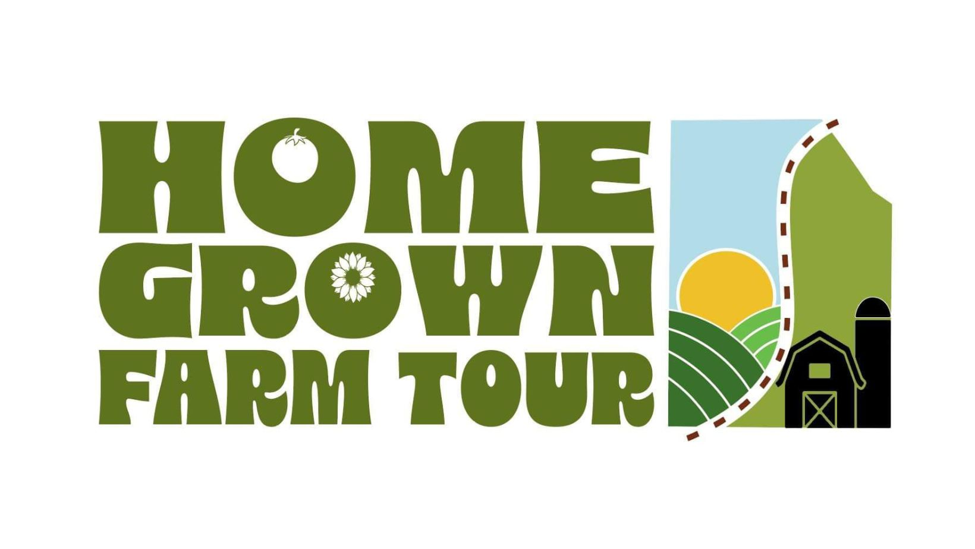

**AGRICULTURAL FARM GRANTS AVAILABLE**

Washington County Homegrown Farm Tour is offering Agricultural Farm Business Grants to a local person producing agricultural products here in Washington County.

General guidelines are:

* The award money cannot be used as general operating funds or as debt reduction.
* The money must be used for an agriculture related business within Washington County.
* The grant recipient must be operating on a budget under $100,000.00 annually.
* This is a onetime award only.
* The winner will be notified in advance and the Grant will be awarded during the Field Dinner on August 24th, 2024 at Edg-Clif Farms and Vineyards.
* The winner will show results or completed project at the following year’s farm tour.

Examples the grant money could be used for include: garden structure, education, professional services, product development, roadside stand, chicken house, etc.

To apply, please send:

1. a description of your agricultural business,
2. name, address, phone number,
3. what you are doing now and
4. how you will use the money (up to $1000) if you are selected.
5. Mail your entry to: Washington County Chamber of Commerce, at 501 E. High St. Potosi MO 63664, Or you may enter by emailing HomeGrownFarmTour@gmail.com

Be sure to put FARM TOUR GRANT APPLICATION in the subject line of your email.

1. **Entries must be received by July 1s, 2024.**

Please submit the application via email to [HomeGrownFarmTour@gmail.com](mailto:HomeGrownFarmTour@gmail.com)

Or via mail to: Home Grown Farm Tour, 501 E. High St., Potosi MO 63664